Name Julius Capul Date 10 / 29 / 2022

Course and Section BSECE 1-1 Activity No. 1

**Title: KNOWING ONESELF**

If you will compare yourself to a particular object/thing, what will it be and why? Write a short essay about it. Draw a picture first before you write your composition.

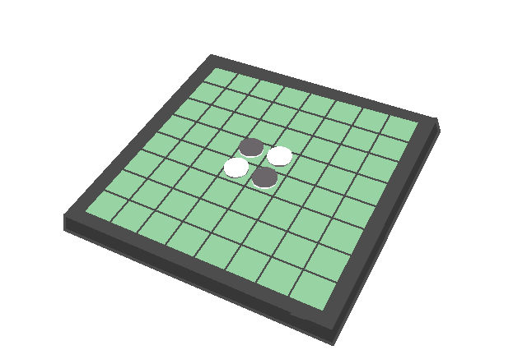

If I have to compare myself to an object, it would be a game of Othello. The game Othello has very simple rules. Very simple tactics combined with a bit of creativity are the least things you need to win a match. I would say that I have a similar approach in life, having a simple goal and spicing it up with a little creativity whenever needed.